SCHOOL INTERVIEW/DISCUSSION GUIDE

Name of school: NAWAMPITI SEED SECONDARY SCHOOL

1a | Does the Facility have a record of all assets provided under UgIFT.  (Obtain a record and verify if it has the costs and numbers supplied | - YES (The head teacher noted them in a note book)
1b | If Not ask how many were supplied and when.

2 | How does this facility Maintain (repair/service/replace) the assets provided under Ugift  - Through the capitation grant the facility only maintains minor repair, services and replacement. For example they fix broken furniture and also replace or buy more new ones

3 | Does the facility take regular record about functionality/ or breakdown of the assets provided?  Nonfunctional/ working, and reasons for non-functionality.  - Most of the equipement supplied at Nawampiti seed secondary school are working and still in good condition | Yes

4 | How has the UgIFT support helped in service delivery in the area, any issues, challenges and any recommendations for better program implementation. | BENEFITS  - The assets supplied by UgiFT have contributed to illiteracy eradication in luuka district  - Employment opportunities to the staff and non-staff  CHALLENGES  - Incomplete playing ground  - Lack of commuters (no ICT equipment received apart )  - Inadequate lab equipment and reagents  - No fence. The facility is surrounded by sugar cane plantations  - No water source at the facility  - Inadequate staff  - Inadequate staff quarters  - No school kitchen put in place besides the staff quarters kitchen  - Inadequate text books  RECOMMENDATIONS  - Consider providing the facility with the necessary ICT equipment  - Fence the facility  - Supply more lab equipment to the facility  - Complete the school playing ground to facilitate CBC  - Consider putting a water source at the facility  - Supply text books to the facility  - Consider building a school kitchen for the school

PROCEED TO VERIFICATION AFTER THIS DISCUSSION

SCHOOL FURNITURE
(School Desks, Office chairs, Laboratory stools, Book shelves)

Name of LG LUUKA DISTRICT
Name of SCHOOL : NAWAMPITI SEED SS

Equipment/ Item | Department | Item  Description | Life in Months | Tag Number ( engrave no.) | Date Of Pur | Date Placed In Service | Recoverable cost | Cost | Acc Dep Cost | Net Book Value | Ytd Deprn | Equipment status | Remarks
School Desks, | education | Long Brown wooden with black metallic stands and a shelve for books |  | Engraved  NWP SS/007 |  |  |  |  |  |  |  | Good and in use | 120 receive , 118 verified and in use
Office Chairs | Education | Coffee brown soft seatr with 4 metallic black stands |  | Not engraved |  |  |  |  |  |  |  | functioning | 34 received, 33 verified and in use
Laboratory stools | Education | Round wooden hard seat with 4 black metallic stands |  | Engraved  NWP SS/023 |  |  |  |  |  |  |  | Good and in use  But some broken | 123 received and 116 verified and in use
Book shelves | education | Wooden in nature, wall mounted with gray metals while others are built on the wall with compatibles |  | Not engraved |  |  |  |  |  |  |  | Good condition | 30 received and verified. Placed in each class
Leaners  Chair | education | Brown single sitter square woolen chair with 4 metallic |  | Engraved  NWP SS/076 |  |  |  |  |  |  |  | Most of them in  good condition  since the school  is still new | 169 received and 162 verified
Office  table | education | Wide wooden brown table with a cabinet |  | Not engraved |  |  |  |  |  |  |  | Good condition  And  functional
Microphone |  | Thin membrane at the top that vibrates when you speak |  | Not engraved |  |  |  |  |  |  |  | functioning | 2 received and verified

ICT ITEMS TO VERIFY
(Desktop Computer, Server Processor, Network Switch 24 Port, Multipurpose Printer, UPS, Projector, Air Conditioners, Server, CCTV Camera)

Name of LG : LUUKA DISTRICT
Name of SCHOOL: NAWAMPITI SEED SS

Equipment/ Item | Department | Asset Number | Item  Description | Life in Months | Tag Number ( engrave no.) | Date Of Pur | Date Placed In Service | Recoverable cost | Cost | Acc Dep Cost | Net Book Value | Ytd Deprn | Equipment status | Remarks
 |  |  |  |  |  |  |  |  |  |  |  |  |  | The school did not receive any ICT equipment

BUILDINGS TO VERIFY
(Non- Residential and Residential, Kitchen, Toilets/Pit latrine Water tanks, Fences etc.)

Name of LG : LUUKA DISTRICT
Name of SCHOOL : NAWAMPITI SEED SS

Equipment/ Item | Department | Item  Description | Life in Months | Tag Number ( engrave no.) | Date Of Pur | Date Placed In Service | Recoverable cost | Cost | Acc Dep Cost | Net Book Value | Ytd Deprn | Equipment status | Remarks
Classroom block | education | Coffee brown and yellow in color with white glasses and ventilators and a lightening conductor on top of the roof |  | Engraved  S.1, S.2 |  |  |  | 150,805,175 |  |  |  | All functioning | The following were verified.  Three classroom blocks with two partitions each.  1 main hall.  1 computer lab.  1 administration block  1 science lab
Administration block |  |  |  |  |  |  |  | 176,868,375
Fence | education |  |  |  |  |  |  |  |  |  |  | Not yet built | Not verified because it is not yet built
Latrines  4 stanced | education | Colored coffee brown with a private wall with 5 stances |  | Not engraved |  |  |  | 40,671,500 |  |  |  | functioning | 6 seen verified.  1 for boys.  1 for girls.  1 for staff.  And 3 on the staff quarters
Science lab |  | 2 units block building painted coffee brown and yellow |  | Engraved  “science lab” |  |  |  | 290,484875 |  |  |  | functioning | Verified and in use
Staff latrines  2 stances |  | 3 toilets each on every staff building painted coffee brown and yellow. |  | Not engraved |  |  |  | 27,538,500 |  |  |  | functioning | Verified and in use
Water tanks | education | Black in color, cylindrical in nature, put on the raised base |  | Not engraved |  |  |  | 5,473,000 |  |  |  | All functioning | 2 were verified.  1 on the administration block  1 on the lab.
Kitchen Blocks | education | Coffee brown and yellow in color with a smoke outlet |  | Not engraved |  |  |  |  |  |  |  | Not Built | Not verified
staff  quarters |  | 3 blocks of 2 units Coffee brown and yellow in color with 2 rooms on each |  | Engraved  ROOM 1 AND 2 |  |  |  | 162,8889,250 |  |  |  | Good condition and functional | 3 received,  verified  In use
staff  kitchen |  | Coffee brown and yellow in color with a smoke outlet |  | Not engraved |  |  |  | 42,056,375 |  |  |  | Good condition and functional | 3 received,  verified  In use
ICT Library |  | 1 block Coffee brown and yellow in color |  | Engraved  library |  |  |  | 399,002,750 |  |  |  | functioning | Verified and in use
staff  latrines |  | Colored coffee brown with a private wall with 2 stances and 2 bathrooms. |  | Engraved  STAFF LATRINES |  |  |  | 27,538,500 |  |  |  | Good condition and functional | 3 received and verified, in use
Sports field/playing ground |  | No grass , no goal posts and no standard measurement |  | Not engraved |  |  |  | 50,000,000 |  |  |  | Not done | Not yet done
Hall |  | Coffee brown and yellow painted long block |  | Engraved  “main hall” |  |  |  | 276,013,375 |  |  |  | functioning | Verified and in use

ASSET VERIFICATION BRIEF REPORT

FACILITY : NAWAMPITI SSS,

CONDUCTED BY

WANDERA SOLOMON AND KIYUBA SALIMU

Introduction.

This brief report presents the findings of the physical asset verification exercise conducted at : NAWAMPITI SSS. The team was warmly welcomed by the Head Teacher (NAWAMPITI SSS) who was the focal person in this exercise (

Findings.

- The facility did not receive and does not have ICT equipments
- Key assets including , furniture and buildings were physically verified and found present
- Most of the assets are not engraved
- All the items were found to be functional and in good physical condition.
- The playing ground is not yet done

Challenges.
- The facility lacks ICT equipment like computers
- Most assets were not engraved thus making the verification exercise very hard because we could not establish whether some equipment that we were verifying were for UGift Or not.
- No fence
- The facility has inadequate accommodation for staff
- The facility has no pitch to conduct the new CBC

Recommendation

Consider providing ICT equipment

Construct additional staff quarters to accommodate and retain critical staff
- Provide a water source .
- Fence the facility
- Complete the playing ground for better CBC implementation

Conclusion.
- The asset verification exercise was successfully completed. All critical assets were verified, are functional, in good condition though most of them were not engraved
- . Addressing the lack of pitch issue, supplying ICT equipment at the Nawampiti sss are the two high priority challenges and if addressed, they will greatly improve service delivery at Nawampiti sss.

NAWAMPITI SEED SECONDARY SCHOOL

PhysicalVerification Pictures.

The table below illustrates some physical status of the verified assets with photographic evidence for NAWAMPITI S SEED SECONDARY SCHOOL

Physical verification photos

NAWAMPITI SSS SIGN MAIN BLOCK | 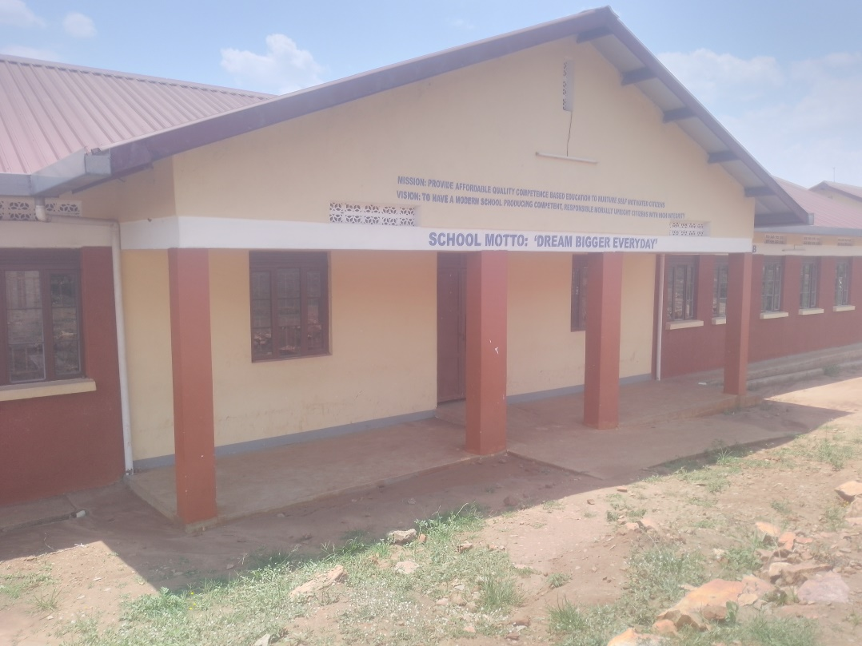
MAIN HALL | 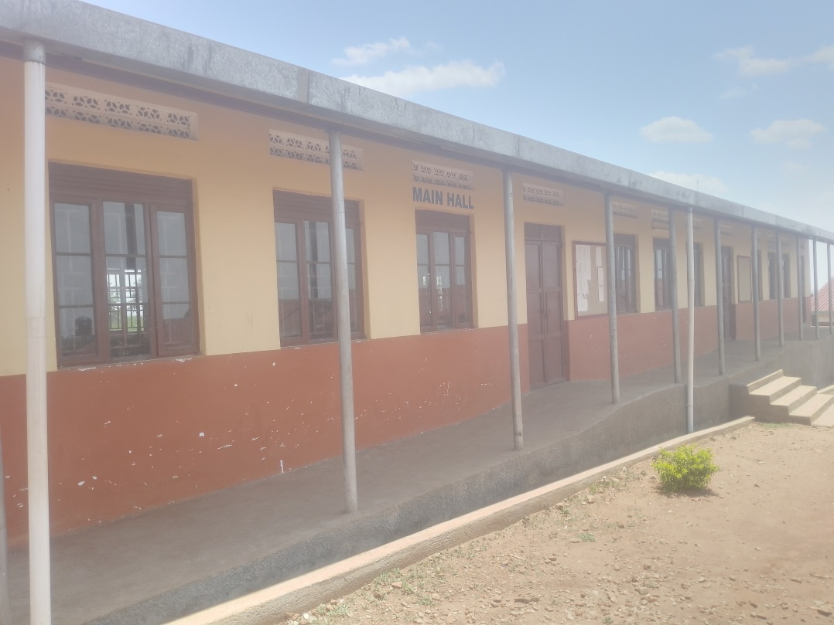
CLASSROOMS | 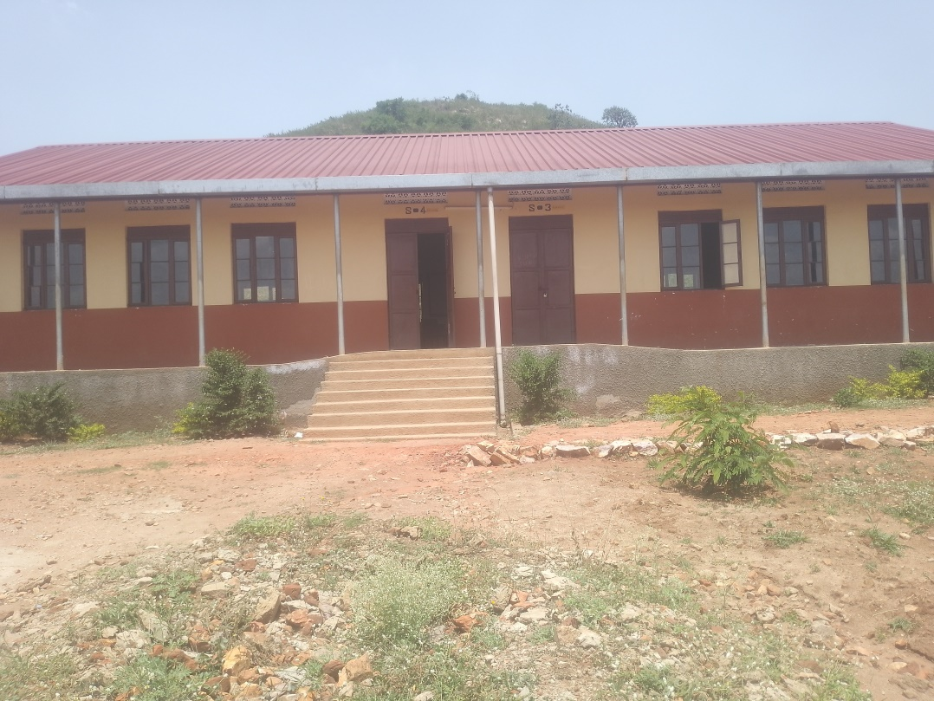
LIBRARY  ENGRAVED”LIBRARY” | 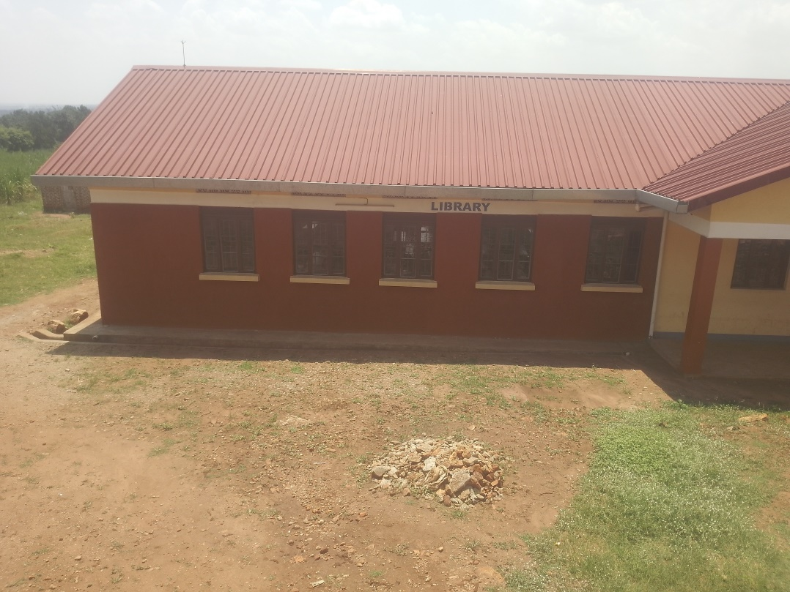
COMPUTER LAB | 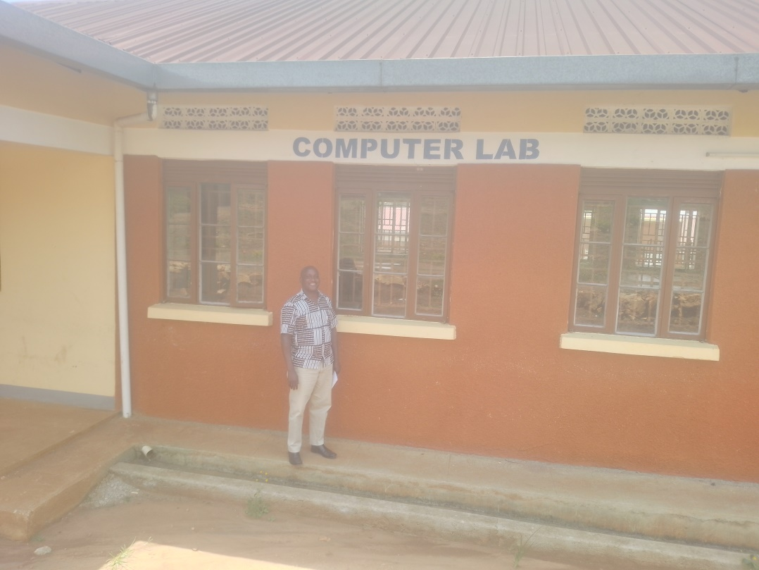
STAFF QUARTERS SECTION  3 STAFF BLOOCKS WITH 2 ROOMS ON EACH | 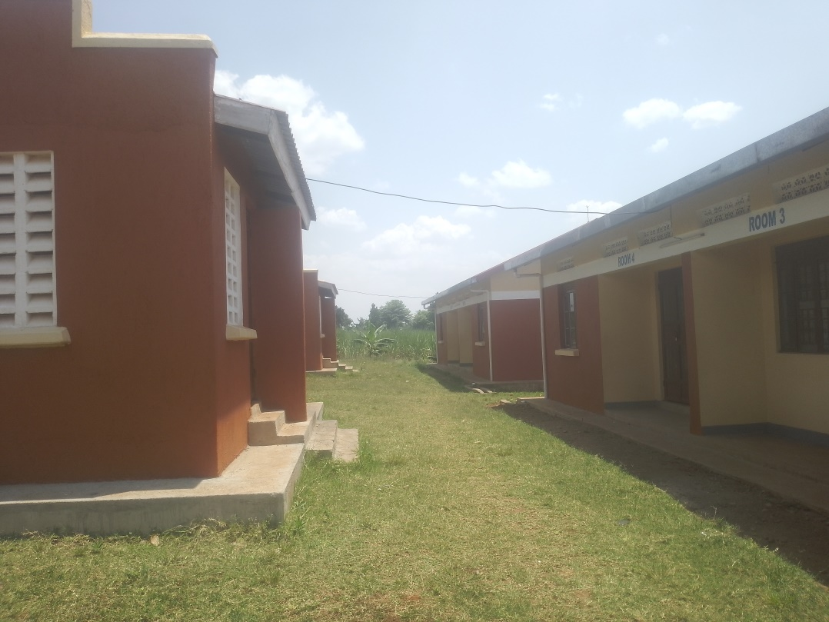
STAFF BUILDING | 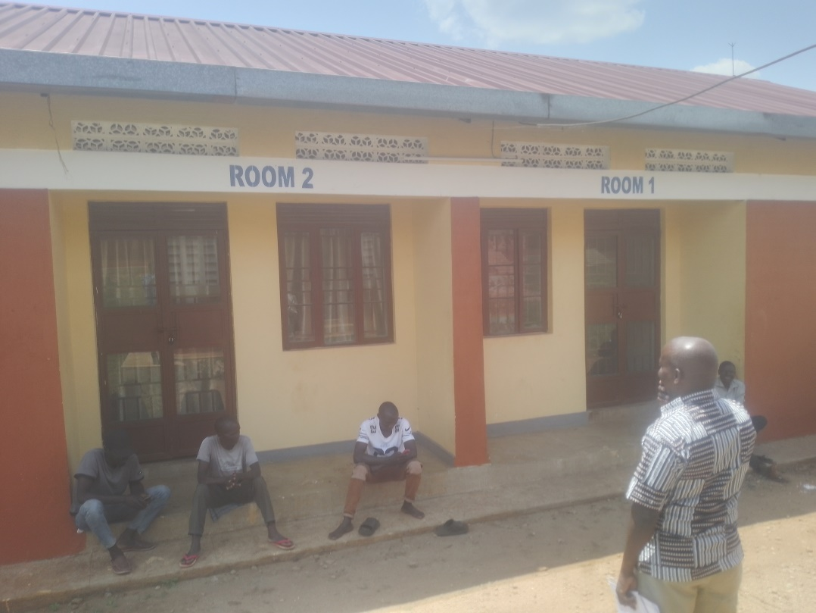
STAFF KITCHEN | 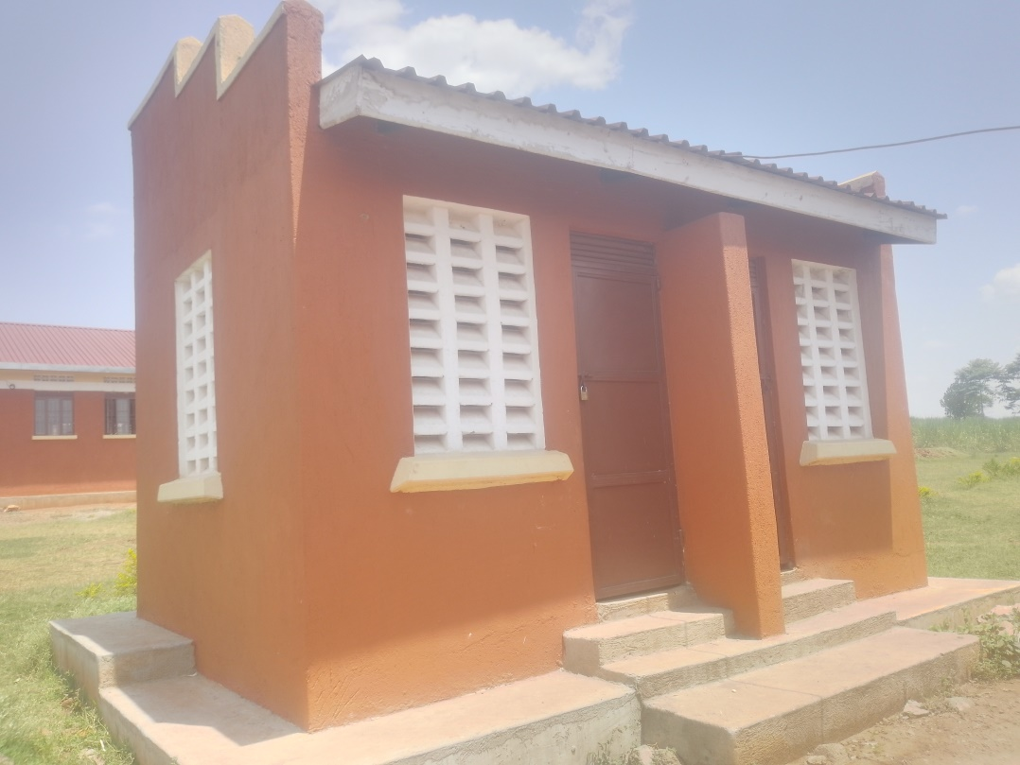
STAFF LATRINES  ENGRAVED | 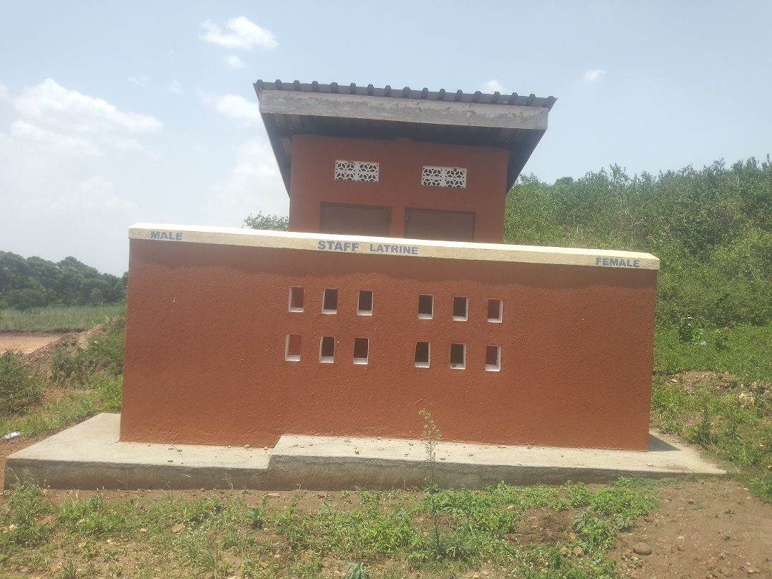
LATRINES FOR THE DISABLED | 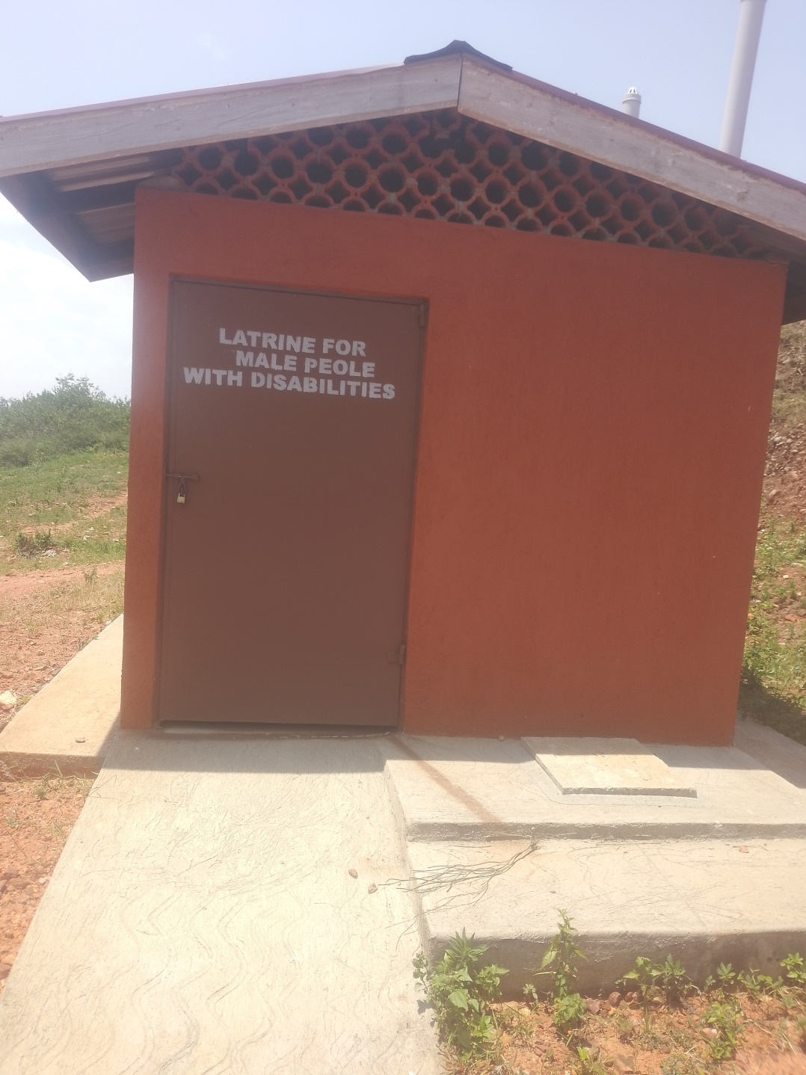
STUDENT LATRINES WITH 4 STANCES | 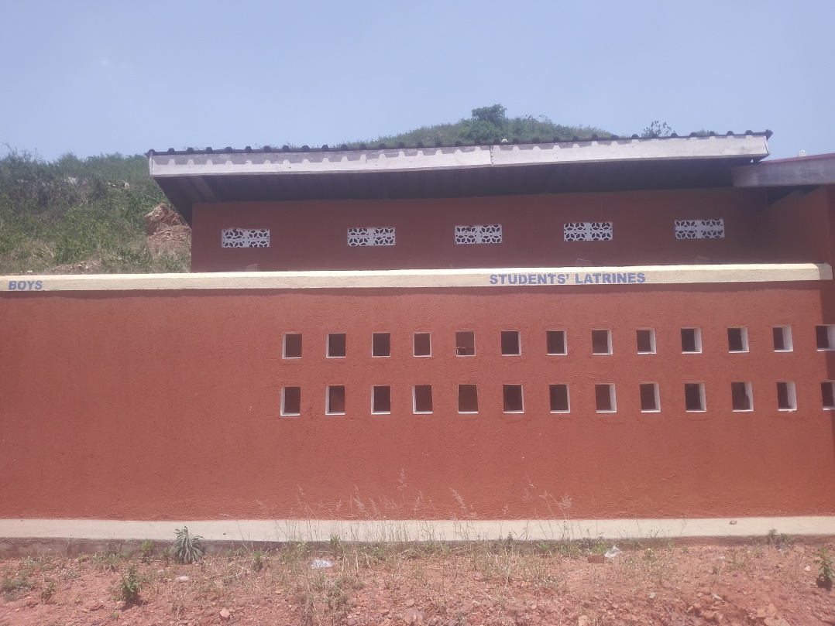
INBUILT WALL CUPBOARDS  NOT ENGRAVED | 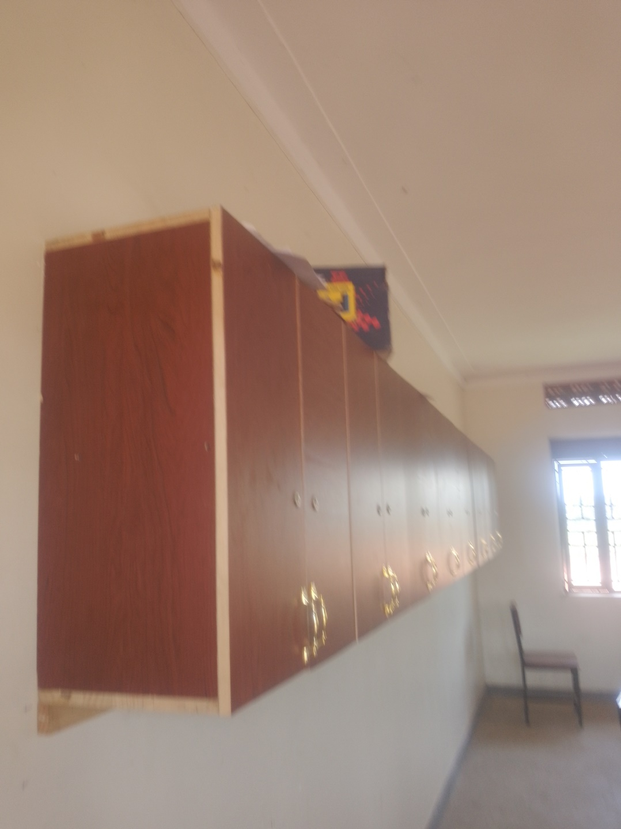
WELL ENGRAVED  SINGLE SEATER CHAIRS | 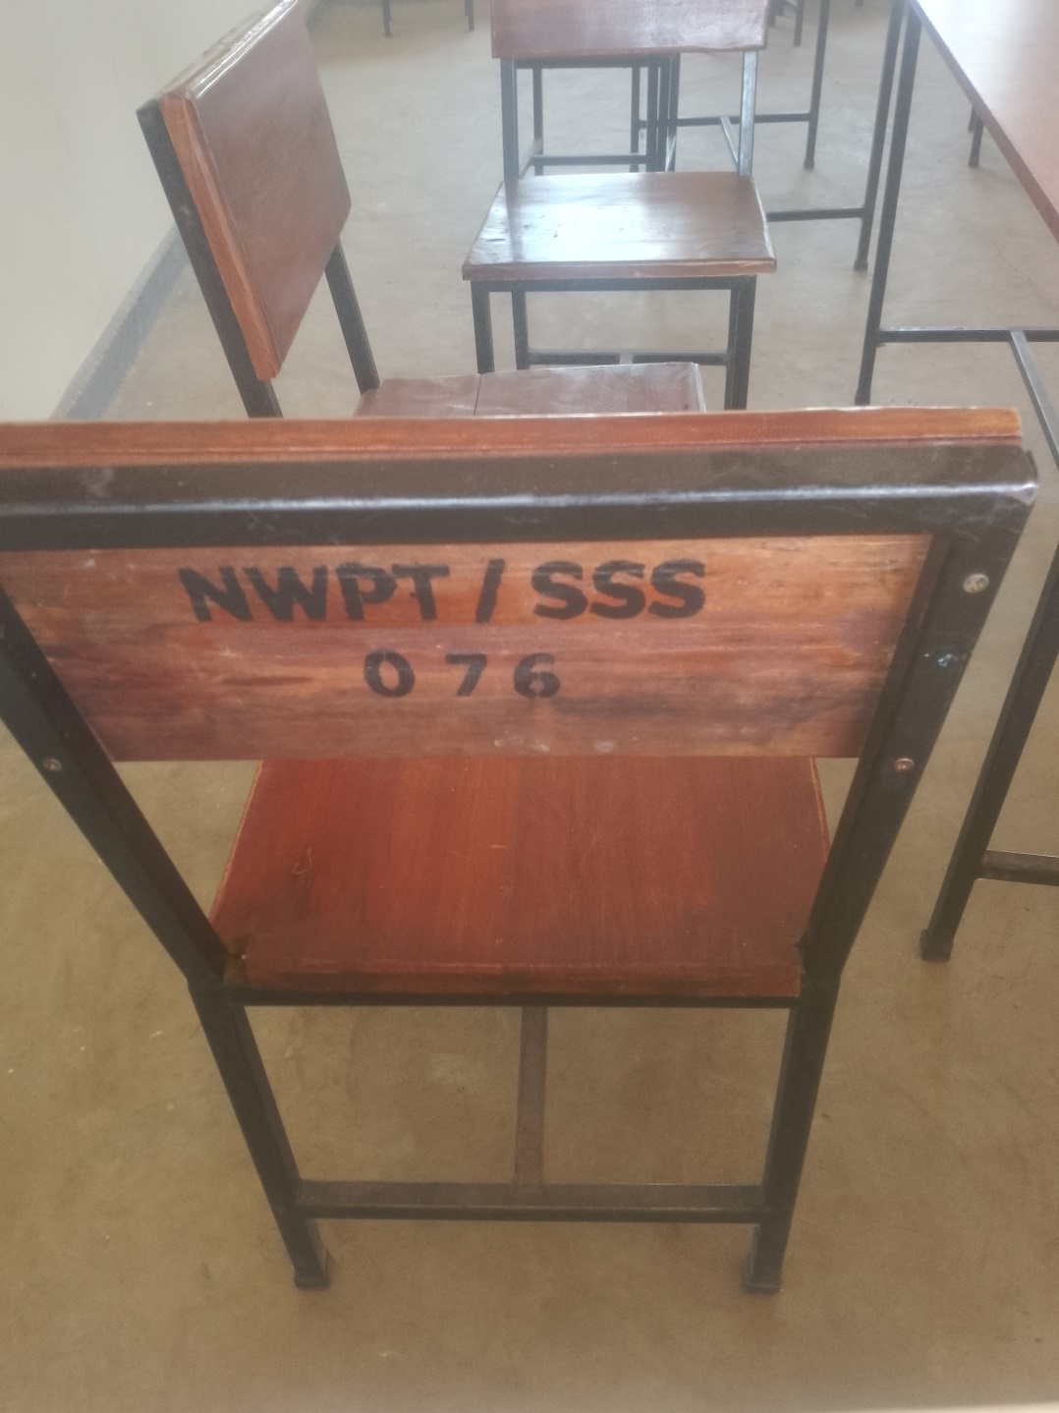
ENGRAVED DESKS | 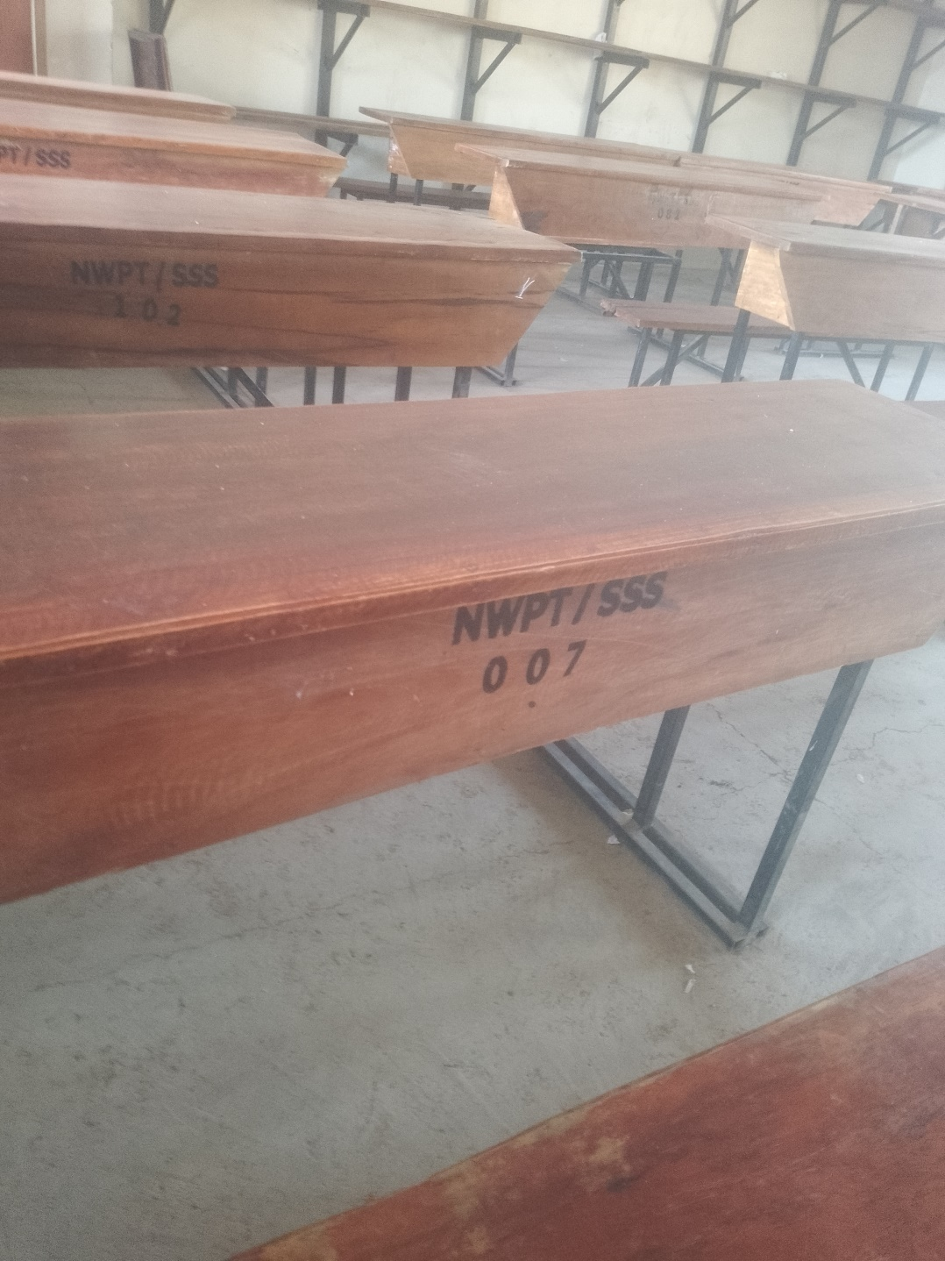
LAB TABLES  NOT ENGRAVED | 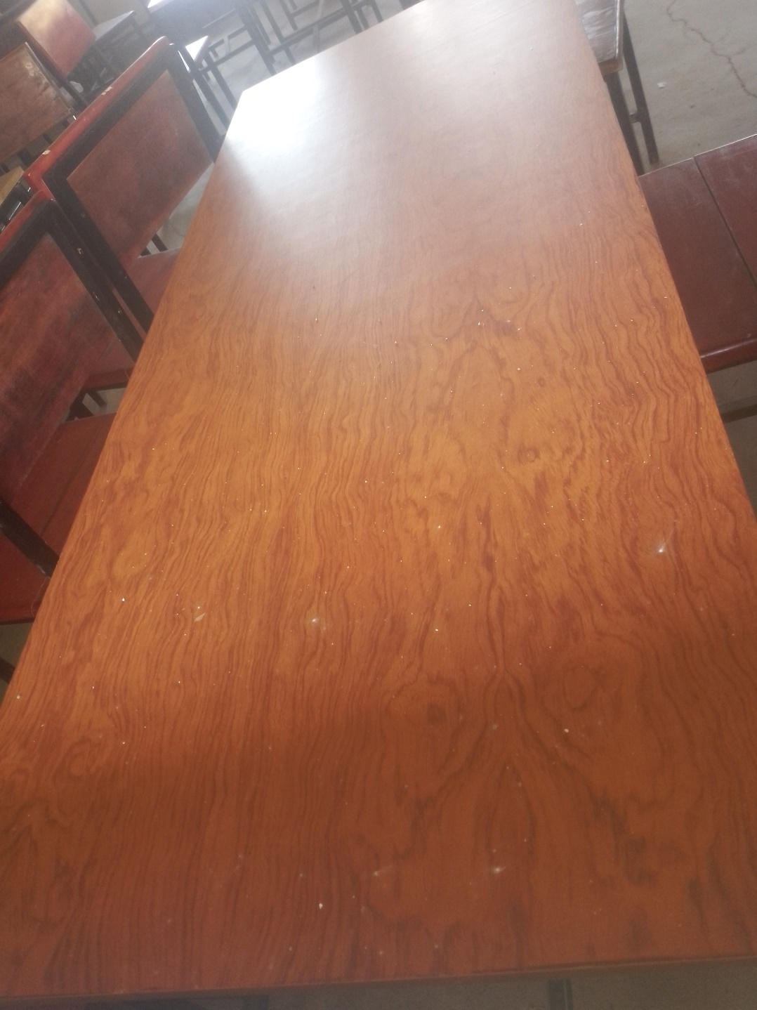
WALL SHELVES IN EACH CLASS | 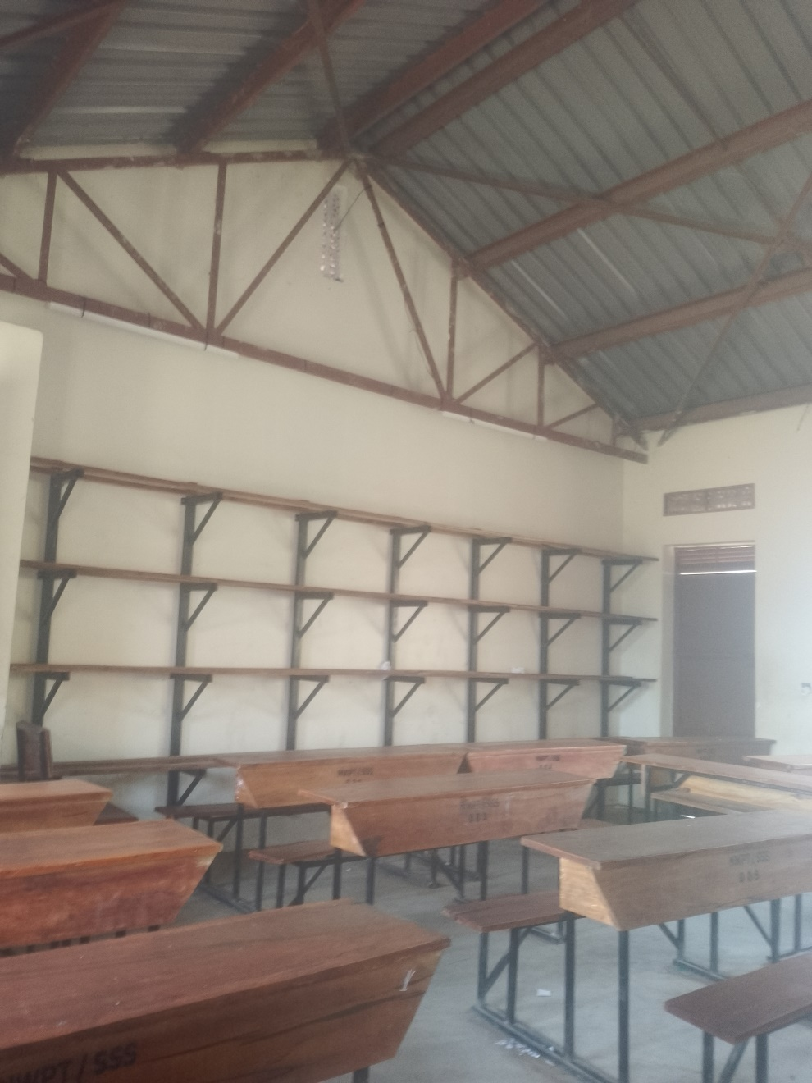
SMALL TANK RAISED ON METALLIC STANDS | 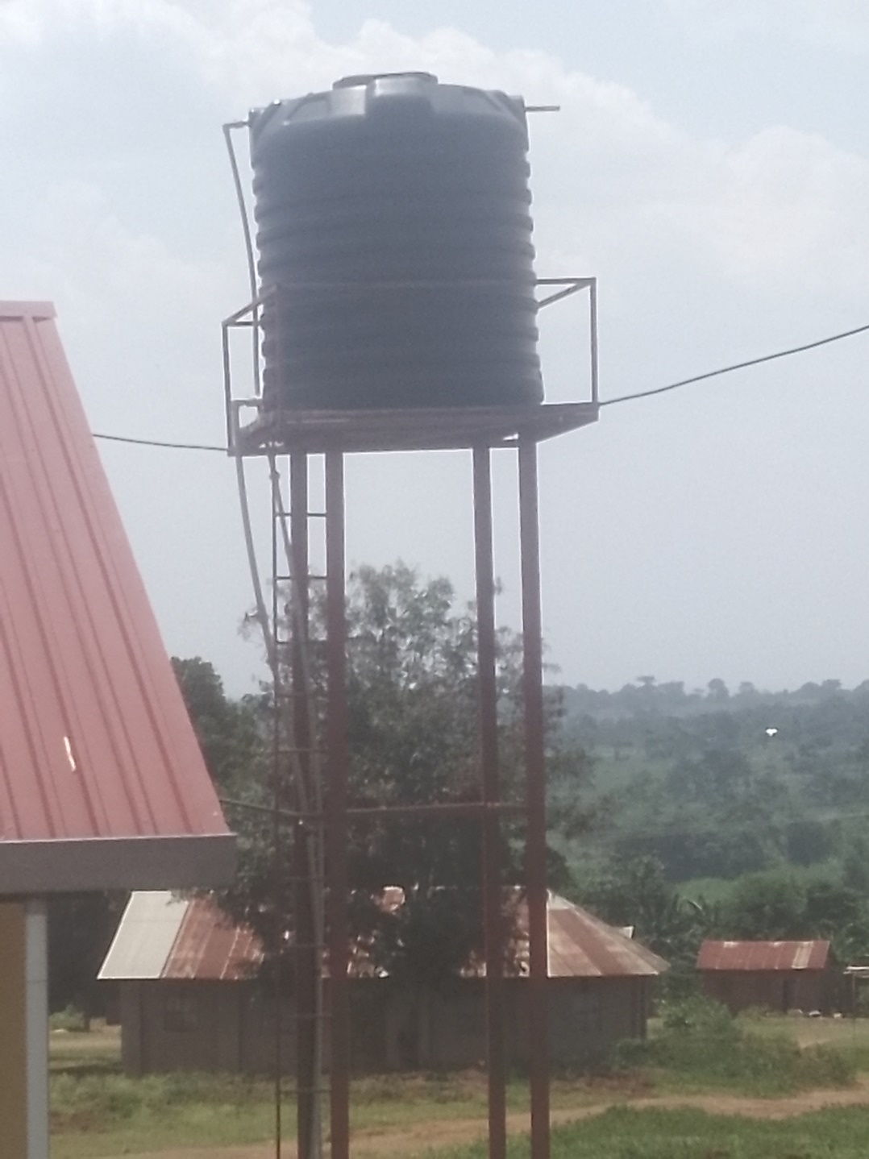
SCHOOL KITCHEN | 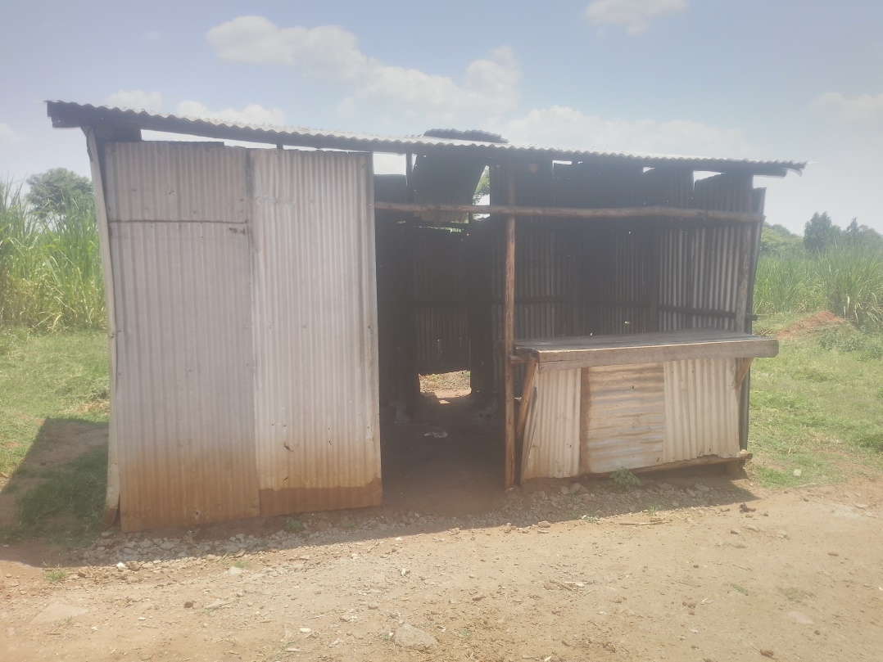
50,000,000M Pitch  WITH NO GRASS,GOAL POSTS, STANDARD MEASUREMENTS | 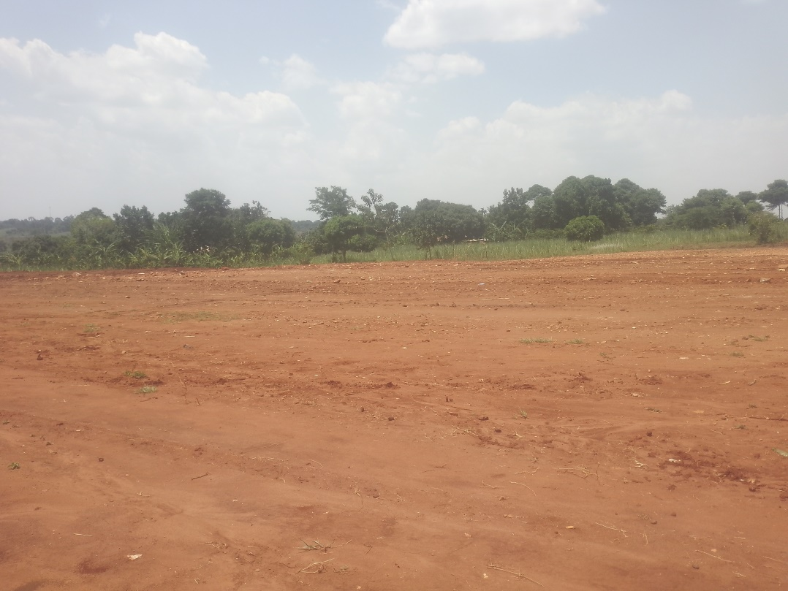
 | 